N-Tron Switch Configuration
A new N-Tron switch will use a default address of 192.168.0.201. It does not need to be changed for normal use, but it may be changed so the switch web page is viewable from the GUI.
Do not do this during production. It will temporarily disable GUI communications with the PLC and robots.
Shut down PaintWorks.
From the start menu, open the control panel.
Open “Network and Sharing Center.”
Open “Change adapter settings” – on the left side of the window.
Open the network card connected to the switch, probably “Local Area Connection”
Press the Properties button.
Open “Internet Protocol Version 4”
Change the IP address from 192.76.251.50 to 192.168.1.50
Press OK to close the Internet Protocol Version 4 window.
Press OK to close the Local Area Connection Properties window.
Press Close to close the Local Area Connection Status window.

Launch a browser window and go to HTTP://192.168.1.201
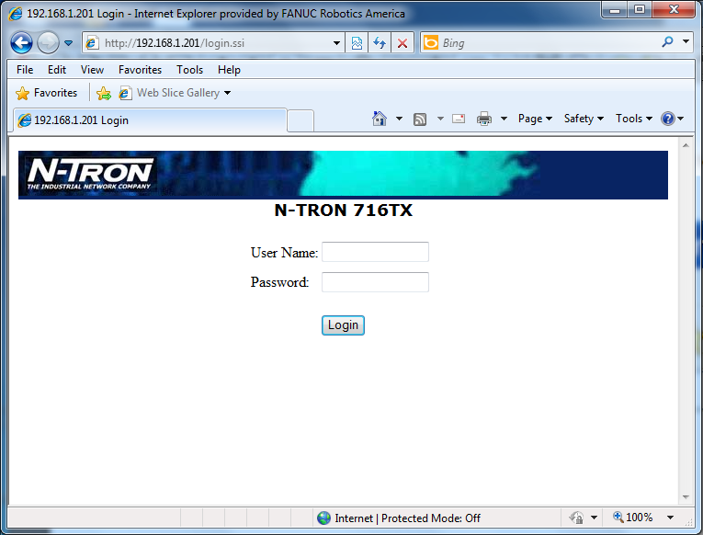

Enter the default username and password:
User Name: admin
Password: admin

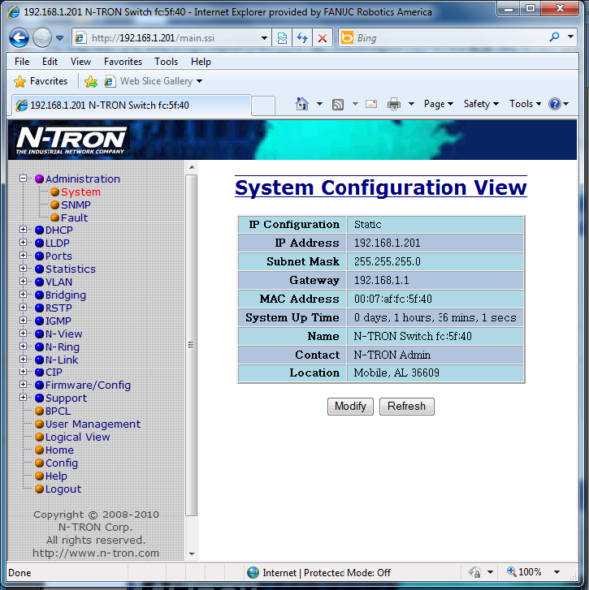

From the selections on the left, go to Administration/System.

Press the “Modify” button.
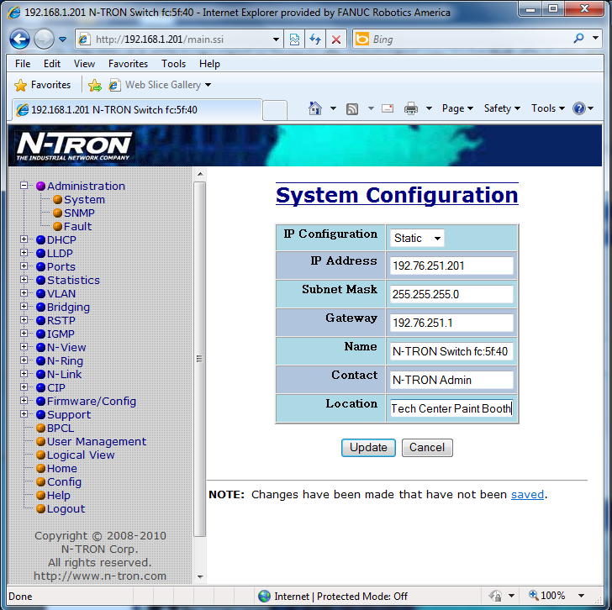
Enter 192.76.251.201 for the IP Address.
Enter 192.76.251.201 for the Gateway.
Enter a name, contact and location if desired.
Press the “Update” button.
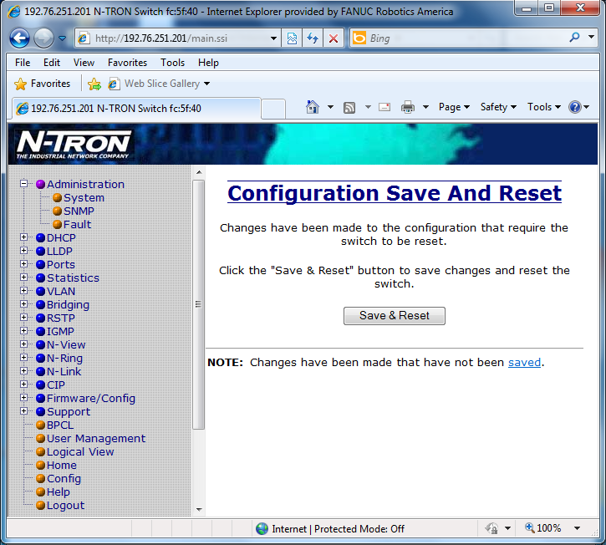
Press the “Save & Reset” button.

Go back to the control panel.

Open “Network and Sharing Center.”
Open “Change adapter settings” – on the left side of the window.
Open the network card connected to the switch, probably “Local Area Connection”
Press the Properties button.
Open “Internet Protocol Version 4”
Change the IP address from 192.168.1.50 to 192.76.251.50
Press OK to close the Internet Protocol Version 4 window.
Press OK to close the Local Area Connection Properties window.
Press Close to close the Local Area Connection Status window.

